

|  |  |
| --- | --- |
| **Submitted By** | **Name :** Zaina Hassan  **Roll no :** SP24-BSE-126 |
| **Subject** | **Object Oriented Programming (OOP)** |
| **Assignment** | **Project (Flight Mangement System) Assignment 3** |

**Submitted to :**

|  |  |
| --- | --- |
| **Moderator** | **Muhammad Shahid Bhatti** |

**Flight Management System**

***Assignment 3***

**Outputs :**

Login window Here **role is admin**

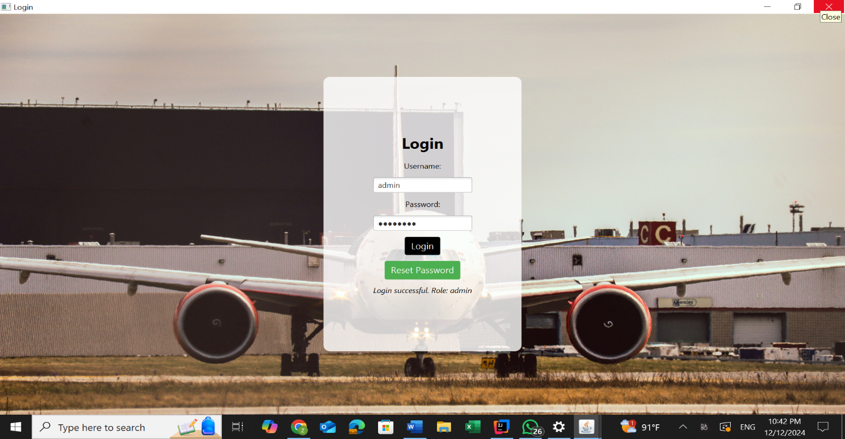

**Reset Password Window**

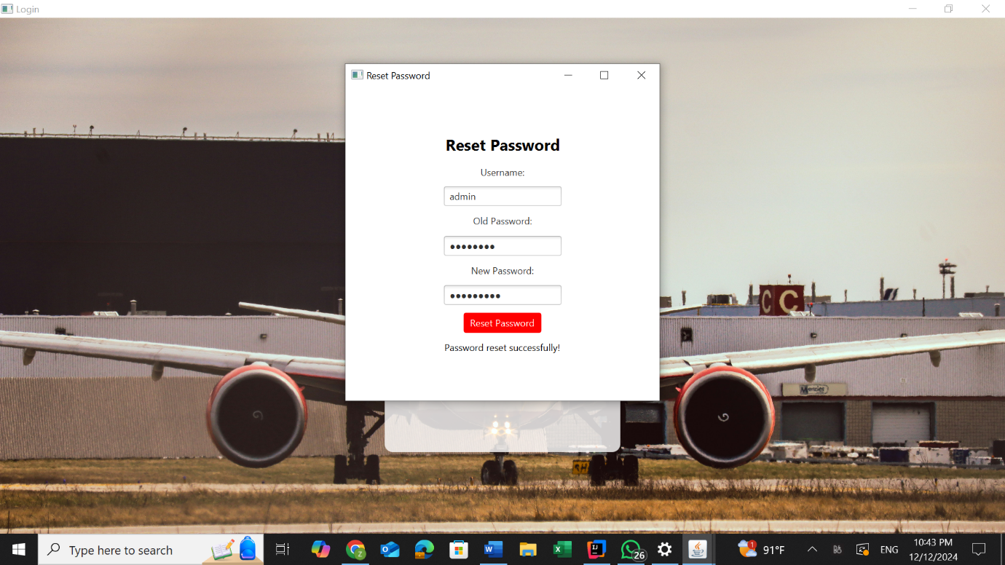

**Admin Panel**

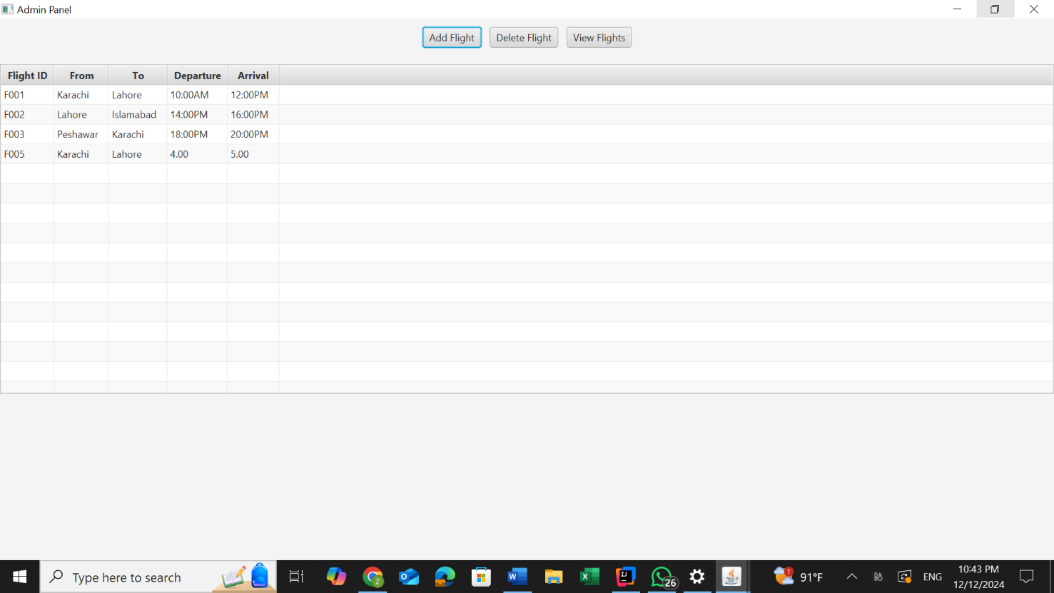

**Adding a Flight**

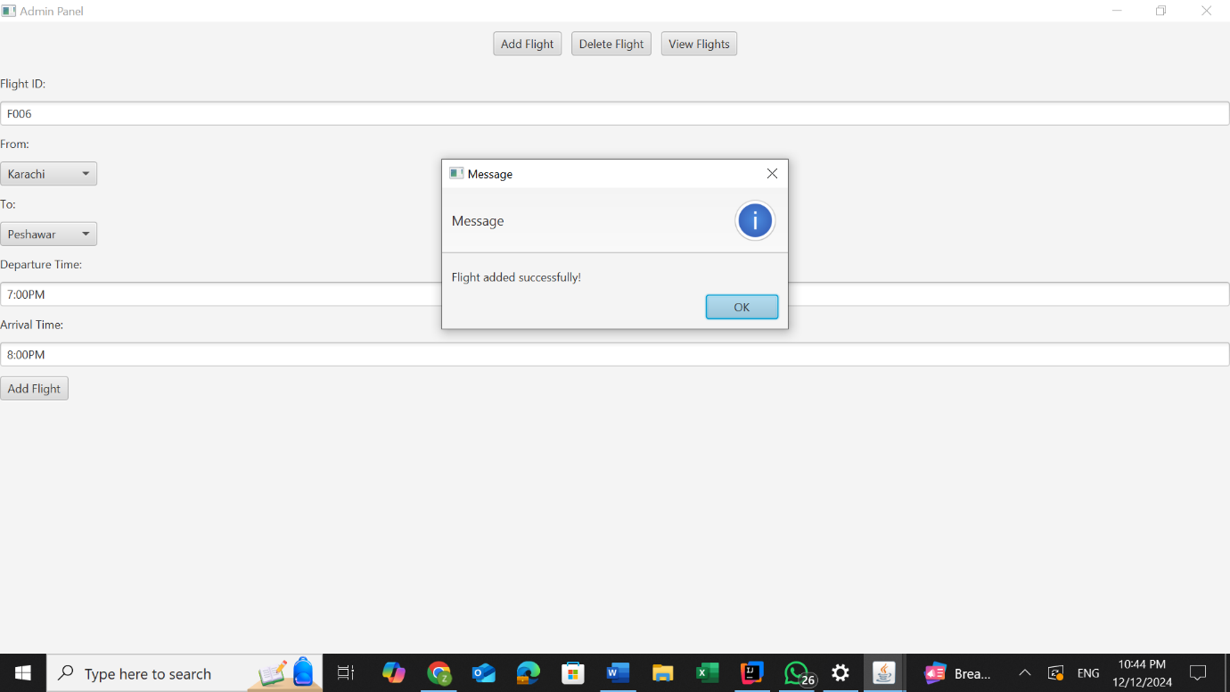

Table after **Adding Flight**

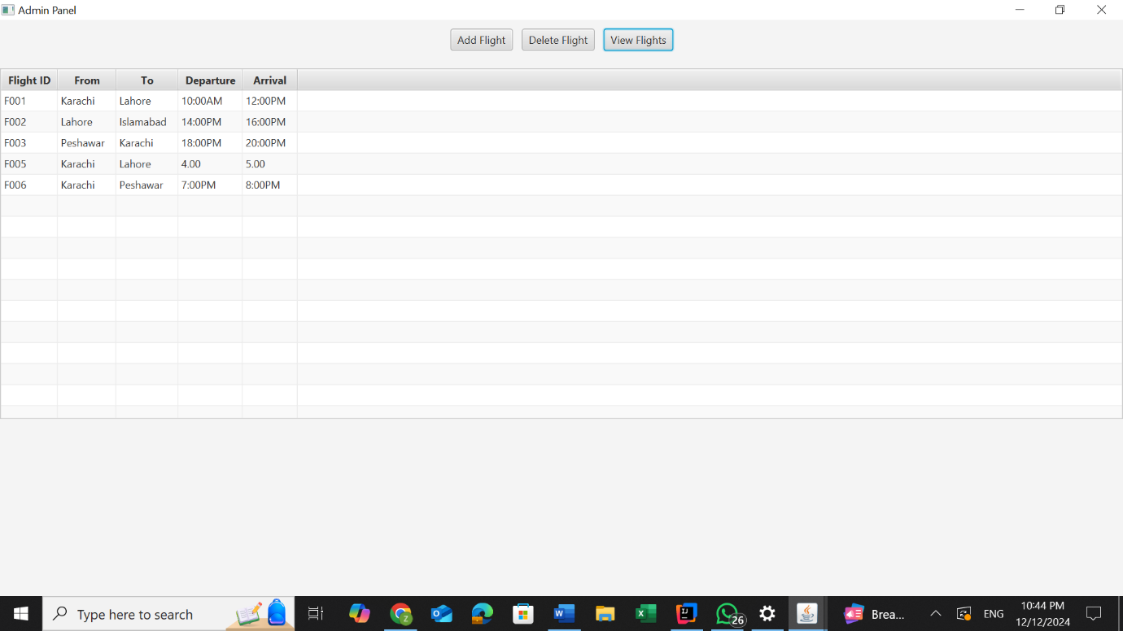

**Deleting a Flight**

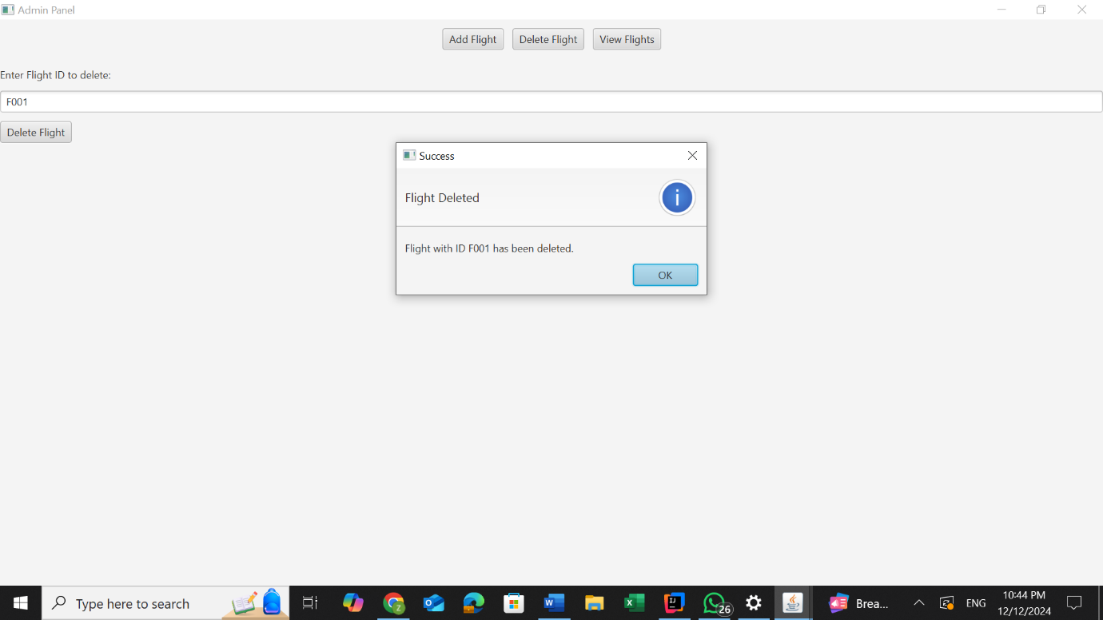

Table after **Deleting A Flight**

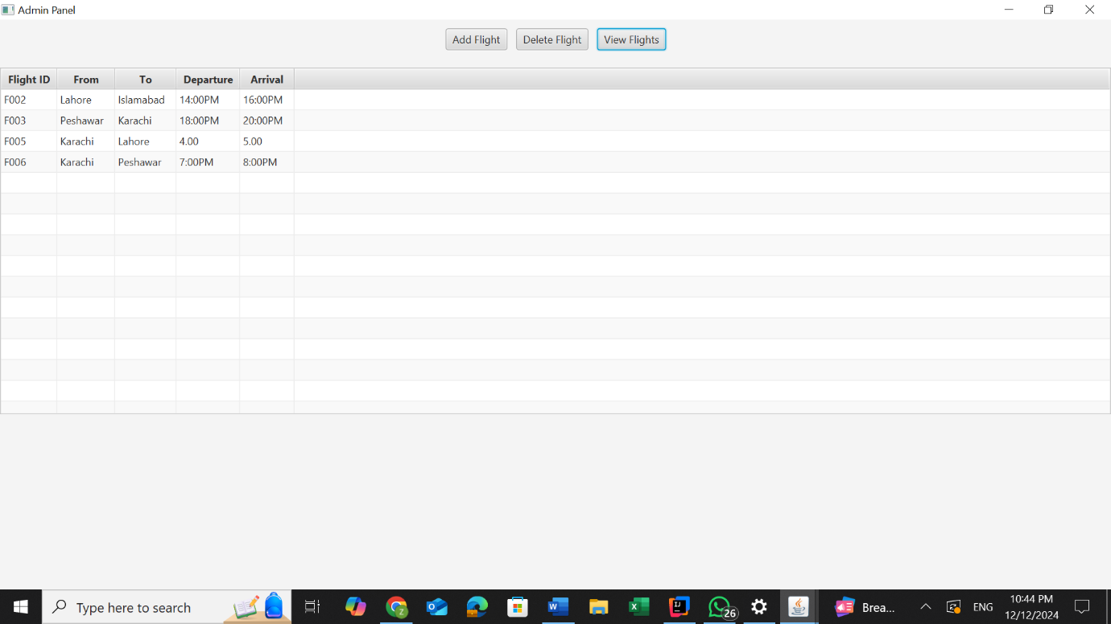

When we enter the Passenger username **Passenger role** is performed

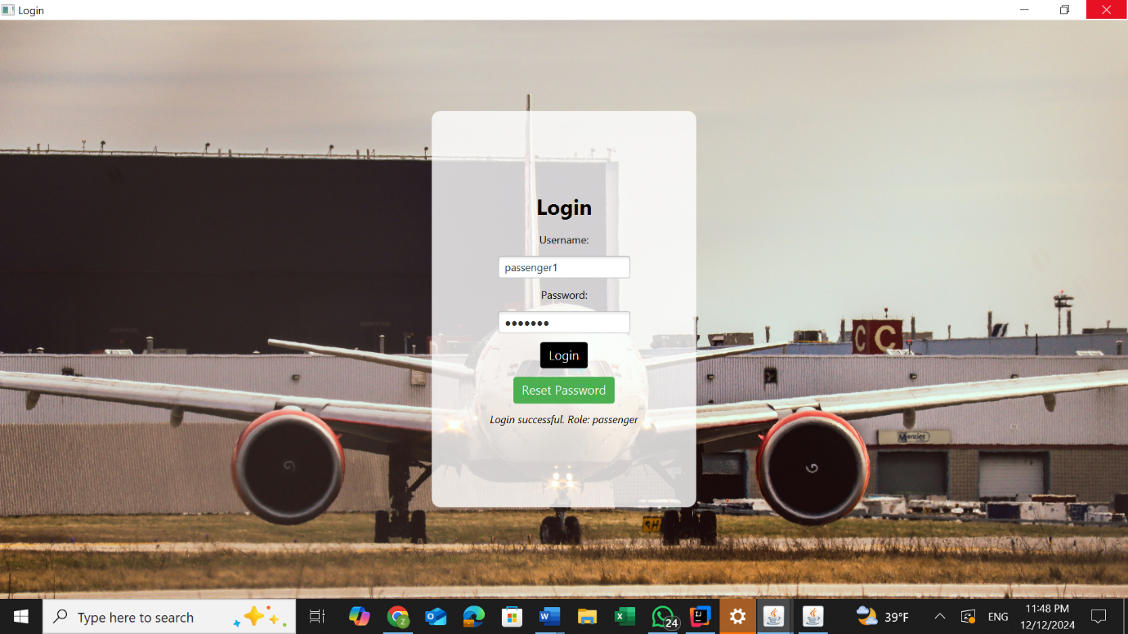

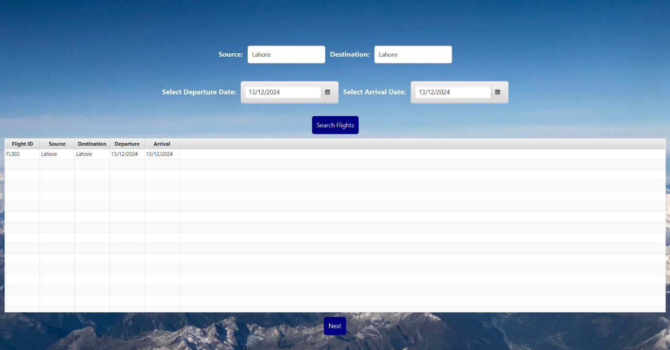**First passenger searches for a flight by entering valid data:**

When next is clicked, PassengerGUI is opened which allows to select and fill in the details of a passenger:

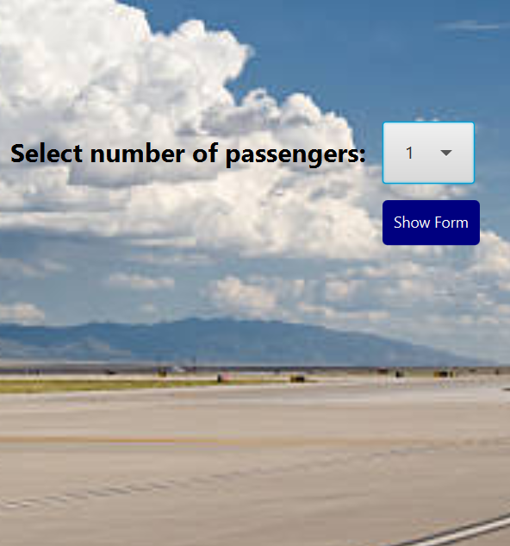

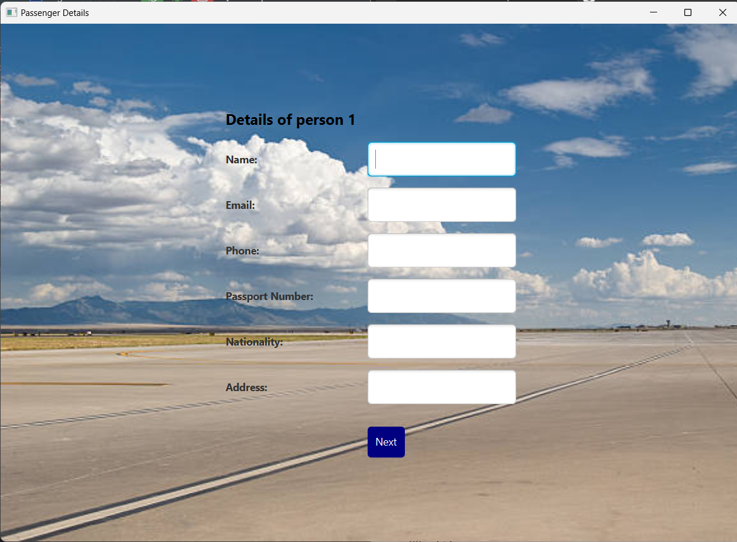**Passengers Data**

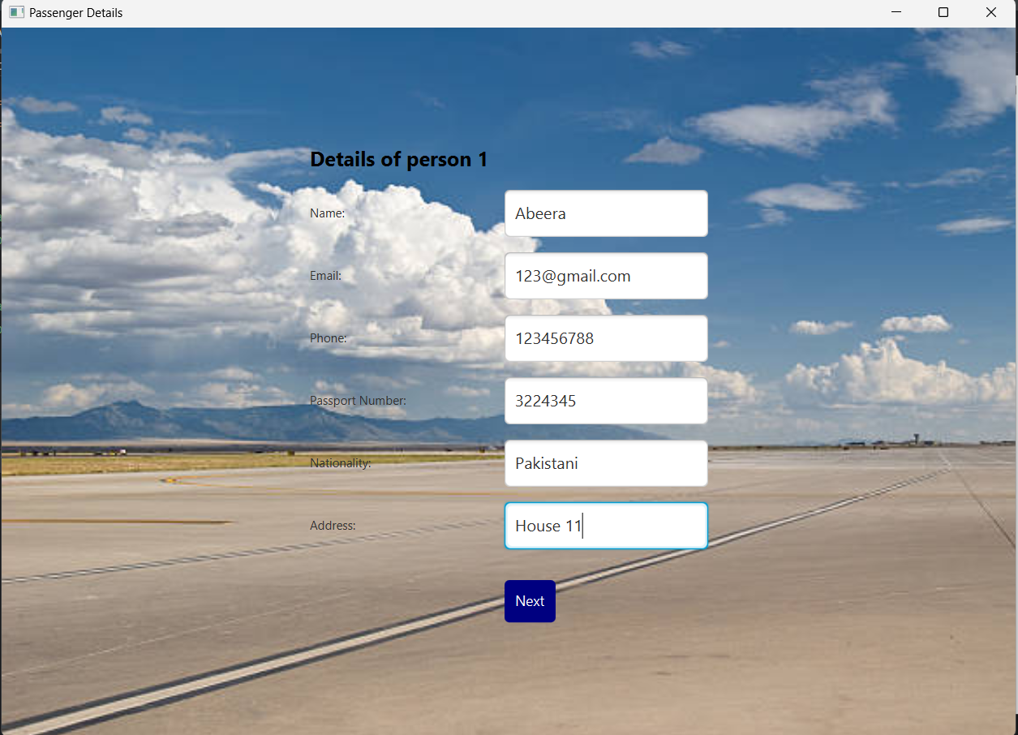The user fills with credible details:

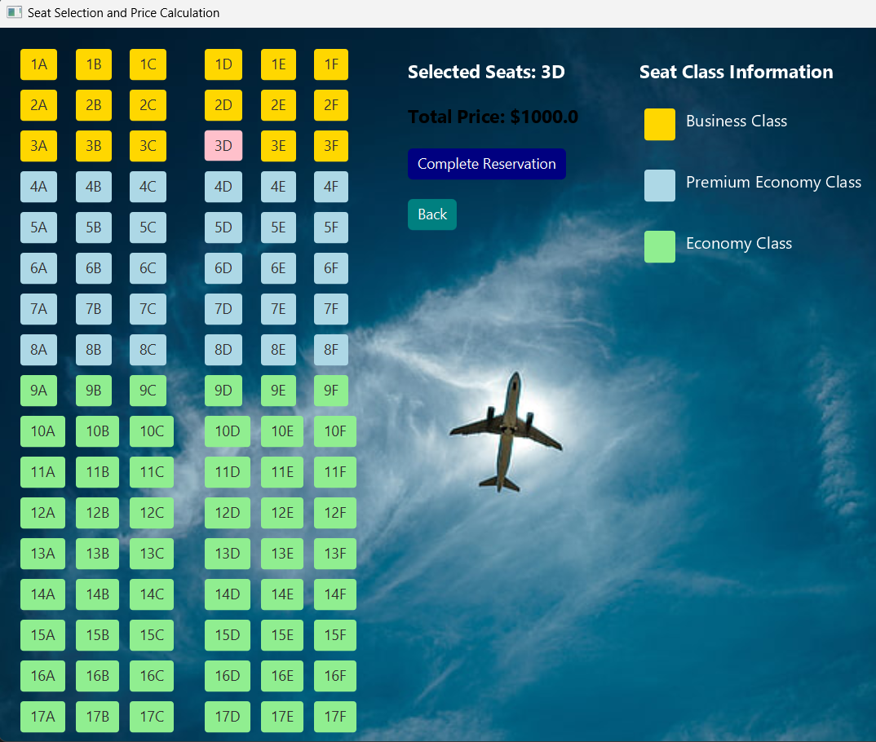When next clicked, it leads to **seatMapGUI** where the passenger will select the seats:

The seat button turns pink upon selection.

When Complete Reservation button is pressed, **ReservationGUI** is executed:

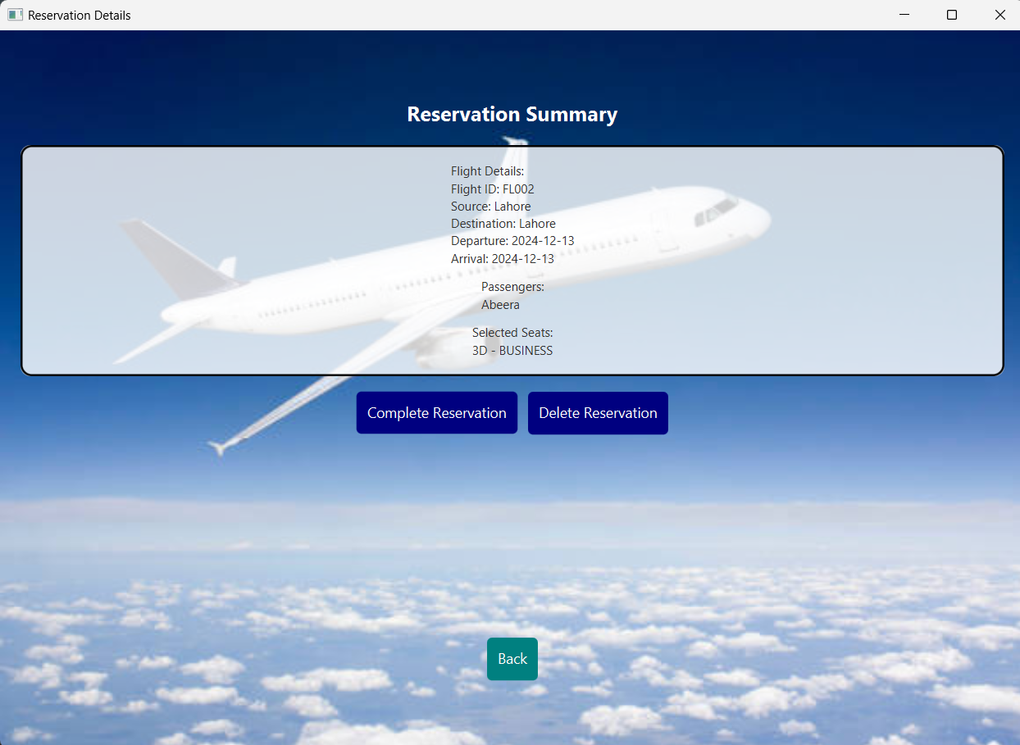

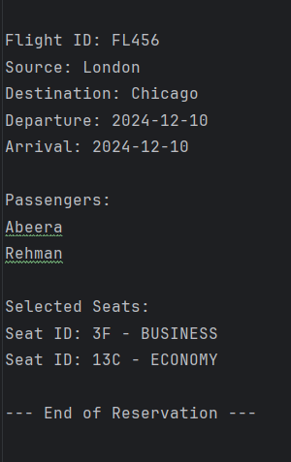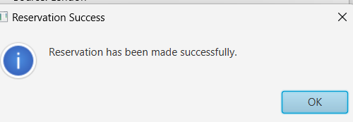

**Upon successful reservation** it will display alert and store it in Allreservation.txt file